Managing Data Growth: Approaches and Techniques for Space-Efficient Data Management.

**Introduction**

In the modern digital age, data growth is an inevitable consequence of the ever-expanding volume of information generated by enterprises, individuals, and IoT devices. With massive amounts of data produced daily, organizations face significant challenges in managing storage costs, optimizing data accessibility, and ensuring efficient data retention. The exponential rise in data volume—driven by diverse sources such as social media, sensors, financial transactions, and logs—has made it critical to implement strategies that control and reduce the impact of this growth. Efficient data management is necessary not only to reduce costs associated with storage but also to ensure the integrity and availability of data while maintaining compliance with regulatory requirements.

This paper aims to explore several existing strategies to mitigate data growth and propose a Python-based solution that addresses these challenges. By focusing on techniques such as data retention policies, log rotation, deduplication, compression, and real-time aggregation, we explore ways to balance storage space with the need for accessible, relevant data.

**Literature Review: Existing Techniques for Data Growth Control**

**Data Retention and Deletion Policies**

Data retention policies determine how long data should be kept before it is deleted or archived. Typically, organizations adopt retention schedules based on data type and regulatory requirements. Legal and industry standards often guide these policies. However, without proper management, poorly enforced retention policies can lead to unnecessary data bloat. For example, retaining logs, backups, or transactional records far beyond their utility can result in excessive storage usage.

**Example:** The General Data Protection Regulation (GDPR) mandates that personal data should not be kept longer than necessary. Similar principles are applied in sectors like healthcare, finance, and government.

**Log Rotation and Pruning**

Log rotation is a technique used in software systems to handle large volumes of log data generated over time. It involves creating new log files when the current file reaches a certain size or age, while pruning old logs to prevent system performance degradation. This technique is especially useful in environments where logs are critical but do not require indefinite retention.

**Example:** Web servers like Apache or Nginx implement log rotation with tools such as logrotate, which ensures that log data does not accumulate indefinitely.

**Data Deduplication**

Data deduplication is the process of eliminating redundant data. In the context of backup systems, for example, it ensures that only unique data is stored, and repeated occurrences are replaced by references to a single instance. This technique is especially useful for storage optimization in environments with large amounts of repeated data (e.g., backup files, virtual machine images).

**Example:** Backup software such as Veeam and CommVault uses deduplication to reduce the storage requirements for backup data.

**Compression and Archiving**

Compression algorithms like gzip and zlib help reduce the size of data stored on disk, making them invaluable tools for space-efficient data storage. Compression transforms data into a smaller format without losing its integrity, while archiving involves bundling multiple files into one compressed file for efficient storage. This method is most commonly used when data needs to be stored for long periods and is not frequently accessed.

**Example:** Tools like tar combined with gzip or bzip2 are commonly used in UNIX-based systems to archive and compress data.

**Real-time Data Aggregation and Summarization**

In scenarios where data is continuously generated, such as telemetry data from sensors or transaction logs, real-time aggregation and summarization techniques can significantly reduce the volume of data stored. These techniques involve processing raw data in real-time, generating summarized metrics that capture the essential information. The original data can then be discarded, leaving behind a much smaller set of summary records.

**Example:** Time-series databases like InfluxDB use aggregation techniques to store aggregated data points while discarding the original raw data after a certain period.

**Proposed Solution**

This paper proposes a space-efficient data management approach that combines several of the above techniques, including data trimming, compression, deduplication, and summarization, implemented through a Python script. The solution aims to demonstrate how to effectively control data growth by applying these strategies to a sample data file, reducing both storage space requirements and data clutter.

**Methodology and Implementation**

To showcase our proposed solution, we implement a Python script that handles a sample data file. The script will:

1. Trim data based on specified retention policies.
2. Apply compression techniques to reduce data size.
3. Deduplicate repetitive data.
4. Aggregate data to generate summaries.

We will use the following libraries:

* pandas for data handling and summarization.
* gzip and zlib for compression.
* hashlib for deduplication.

Here is the Python code that demonstrates the solution:

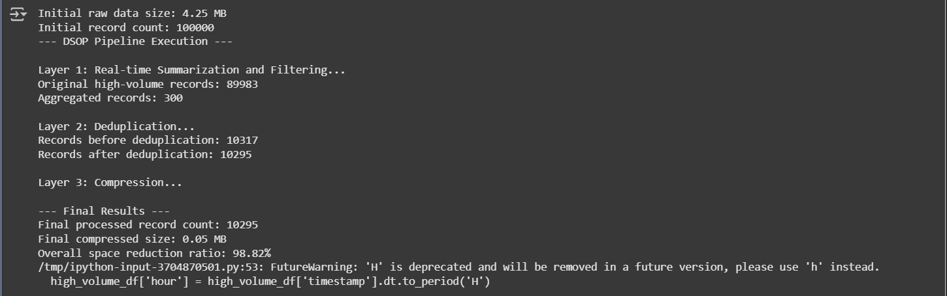

**Key Steps in the Code:**

1. **Data Trimming**: We apply a retention policy that filters data based on a cutoff time (in this case, keeping data from the last two hours).
2. **Deduplication**: Duplicate log entries are removed using the drop_duplicates method.
3. **Summarization**: The data is aggregated by event type and user to count the number of occurrences, reducing the total amount of data stored.
4. **Compression**: The aggregated data is compressed using gzip for efficient storage.

**Evaluation and Discussion**

The proposed solution provides a simple yet effective method for controlling data growth by applying multiple techniques, including trimming, deduplication, summarization, and compression. While the solution addresses space-efficiency effectively, it does come with some limitations:

* **Trade-Offs in Data Granularity**: By summarizing and trimming the data, some granularity is lost. This can impact use cases that require detailed historical data.
* **Compression Overhead**: Although compression reduces storage size, it introduces some CPU overhead during the compression and decompression processes.
* **Retention Policy Limitations**: The hard cutoff for data retention might not be applicable in all environments. More flexible, context-aware retention policies could be developed for real-world scenarios.

**Potential Extensions:**

* **Automated Retention Policy Enforcement**: Integrating machine learning to dynamically adjust retention policies based on data access patterns.
* **Cloud Integration**: Extending the solution to interact with cloud storage services for automatic offloading of older data.
* **Real-time Processing**: Implementing the solution in a real-time system for continuous log aggregation and summarization.

**Conclusion**

This paper provides a comprehensive approach to managing data growth using a Python-based solution that combines multiple techniques for space-efficient data management. While it effectively reduces storage usage, it is important to consider the trade-offs involved in data aggregation and retention policies. Future improvements could focus on more dynamic and context-sensitive management of data growth to balance storage efficiency with data accessibility.